# Council Assessment Report

|  |  |
| --- | --- |
| **Panel Reference** | PPSHCC-53 |
| **DA number** | DA/1166/2020 |
| **LGA** | Lake Macquarie City Council |
| **Proposed development** | Retail premises with ancillary business premises, vehicle repair station, and service station |
| **Permissibility** | Retail premises are permitted with consent in the B4 and B7 zones under the Lake Macquarie Local Environmental Plan 2014.  Stormwater infrastructure is permitted with consent in the SP1 zone under State Environmental Planning Policy (Infrastructure) 2007. |
| **Street address** | 2A Main Road Boolaroo (Lot 599 DP 1228699) |
| **Zoning** | B4 Mixed Use  B7 Business Park  SP1 Special Activities |
| **Applicant/Owner** | Applicant: Tim Hill on behalf of Costco Wholesale Australia Pty Ltd  Owner: Hunter and Central Coast Development Corporation |
| **Date of DA lodgement** | 3 August 2020 |
| **Number of submissions** | Five submissions were received in objection to the development.  Notified on one occasion from 11 August 2020 – 28 August 2020. |
| **Integrated development** | Subsidence Advisory NSW |
| **External referrals** | Transport for NSW (TfNSW)  Ausgrid  Hunter Water Corporation (HWC)  NSW Police |
| **Recommendation** | Approval, subject to conditions of consent |
| **Regional Development Criteria (Schedule 7 of the SEPP (State and Regional Development) 2011** | General development over $30 million  CIV $49 million |
| **List of all relevant s4.15(1)(a) matters** | * Environmental Planning and Assessment Act 1979 * Environmental Planning and Assessment Regulation 2000 * Coal Mine Subsidence Compensation Act 2017 * State Environmental Planning Policy No. 33 – Hazardous and Offensive development * State Environmental Planning Policy No. 55 – Remediation of Land * State Environmental Planning Policy No. 64 – Advertising and Signage * State Environmental Planning Policy (Coastal Management) 2018 * State Environmental Planning Policy (Infrastructure) 2007 * Lake Macquarie Local Environmental Plan 2014 (LMLEP 2014) * Lake Macquarie Development Control Plan 2014 (LMDCP 2014) |
| **List all documents submitted with this report for the Panel’s consideration** | Attachment A: Draft Conditions  Attachment B: Architectural Plans  Attachment C: Landscape Plans  Attachment D: Engineering and Subdivision Plans  Attachment E: Transport for NSW Response  Attachment F: Transport for NSW Recommended conditions  Attachment G: Addendum Traffic Report  Attachment H: Economic Impact Assessment  Attachment I ; Response to request for information |
| **Clause 4.6 request/s** | N/A |
| **Report prepared by** | Glen Mathews, Senior Development Planner |
| **Report date** | 17 November 2020 |

|  |  |
| --- | --- |
| **Summary of s4.15 matters**  Have all recommendations in relation to relevant s4.15 matters been summarised in the Executive Summary of the assessment report? | **Yes** |
| **Legislative clauses requiring consent authority satisfaction**  Have relevant clauses in all applicable environmental planning instruments where the consent authority must be satisfied about a particular matter been listed, and relevant recommendations summarized, in the Executive Summary of the assessment report? | **Yes** |
| **Clause 4.6 Exceptions to development standards**  If a written request for a contravention to a development standard (clause 4.6 of the LEP) has been received, has it been attached to the assessment report? | **N/A** |
| **Special Infrastructure Contributions**  Does the DA require Special Infrastructure Contributions conditions (S7.24)? | **N/A** |
| **Conditions**  Have draft conditions been provided to the applicant for comment? | **Yes** |

## Executive summary

Consent is sought for a retail premises with ancillary business premises, vehicle repair station, and service station, to operate as a Costco Wholesale warehouse.

The development comprises the following:

* Costco warehouse building with internal gross floor area (GFA) of approximately 13,100m2, consisting of:
  + retail floorspace,
  + ancillary business premises for preparation of products and provision of services (i.e. bakery, butcher, eye care),
  + ancillary food and drink premises,
  + four bay tyre fitment centre,
  + amenities and staff facilities.
* service station, consisting of:
  + 12 fuel pumps,
  + fuel canopy,
  + data hut,
  + pay at pump service
* 822 car parking spaces;
* landscaping;
* signage.

General Terms of Approval have been provided from Subsidence Advisory NSW as integrated development under the Coal Mine Compensation Act 2017.

Consultation with Transport for NSW, Ausgrid, and Hunter Water Corporation was undertaken during the assessment. No objections were raised by these authorities in relation to the development.

The development was notified to the NSW Police and no response was received during the assessment of the application.

Five submissions were received from three parties. All submissions objected to the development

The site is constrained by potential acid sulfate soils. This matter has been adequately addressed and does preclude development of the site.

Consideration has been given to proposed earthworks, with works deemed acceptable.

The development has demonstrated the site is capable of being provided with required essential services and infrastructure including water, sewer, electricity, stormwater and vehicle access.

The site is mapped as a Key Site under the Lake Macquarie Local Environmental Plan 2014. The development is consistent with the provisions of the Key Site, and consent can be granted.

The development is not a potentially hazardous industry in accordance with State Environmental Planning Policy No. 33 – Hazardous and Offensive development.

The land has been remediated and is suitable for use for commercial/ industrial development in accordance with State Environmental Planning Policy No. 55 – Remediation of Land.

Signage is consistent with the aims and objectives of State Environmental Planning Policy No. 64 – Advertising and Signage, and satisfies the assessment criteria under Schedule 1 of the SEPP.

The development will not have adverse impacts to the Coastal Zone in accordance with State Environmental Planning Policy (Coastal Management) 2018.

The development has been assessed to be compliant with applicable State, Regional and Local Environmental Planning Instruments and Policies, in accordance with Section 4.15(1) of the Environmental Planning and Assessment Act 1979. Planning instruments addressed within this report include:

* Environmental Planning and Assessment Act 1979
* Coal Mine Subsidence Compensation Act 2017
* Environmental Planning and Assessment Regulation 2000
* State Environmental Planning Policy No. 33 – Hazardous and Offensive development
* State Environmental Planning Policy No. 55 – Remediation of Land
* State Environmental Planning Policy No. 64 – Advertising and Signage
* State Environmental Planning Policy (Coastal Management) 2018
* State Environmental Planning Policy (Infrastructure) 2007
* Lake Macquarie Local Environmental Plan 2014
* Lake Macquarie Development Control Plan 2014

The development is considered to be in the public interest and worthy of support subject to conditions.

## Reasons for determination

The development has been assessed against the relevant matters for consideration applicable to the land and proposed development as outlined in Section 4.15 of the Environmental Planning and Assessment Act 1979 as follows:

* the development meets the requirements of the Lake Macquarie Local Environmental Plan 2014 and other relevant environmental planning instrument;
* consideration has been given to proposed instruments which have been the subject of public consultation;
* the development generally complies with Lake Macquarie Development Control Plan 2014 with any variations to the controls outlined and justified within this assessment report;
* considering the likely impacts of the development on the natural and built environments, the development is considered to provide balanced and appropriate outcomes;
* the suitability of the site for the development, including characteristics and constraints of the land have been considered and it was found the land as being suitable for the development;
* matters of public interest have been considered in relation to social, economic and environmental outcomes.

Based on the balance of the matters considered, the application is recommended for approval.  Details of the assessment are contained in the assessment report below.

## Community interest

The assessment of the proposed development under Section 4.15(1) of the Environmental Planning and Assessment Act 1979 has considered community views. The application was notified in accordance with the Council’s Community Participation Plan as adopted by Lake Macquarie City Council.

The application was notified on one occasion following lodgement from 11 August 2020 to 28 August 2020.

A total of five submission were received from three parties. All submissions were in objection to the development. Three responses were received in relation to the development during the notification period, and a further two were received after the formal notification period.

The matters raised in all of these submissions have been considered as part of the assessment of the development. For detailed comment regarding the matters raised in the submissions refer to Section 4.15(1)(d) of this report.

## Site, context and development history

### Background

#### Rezoning

Approximately 20ha of land at the former Pasminco Lead Smelter was rezoned from R2 Low Density Residential and R3 Medium Density Residential, to B4 Mixed Use and B7 Business Park on 10 July 2020. The subject site is included within the rezoned land.

Clause 7.24 of the Lake Macquarie Local Environmental Plan 2014 (LMLEP 2014) was introduced to enable large format retail at the site, subject to a minimum development area, minimum gross floor area, and operation by a single operator.

#### Subdivision

A two into twelve lot subdivision of the former Pasminco Lead Smelter was approved by Council on 9 October 2020. The development will be contained within approved future lot 1011, which will be delivered in stage one of subdivision works.

#### Lodgement and assessment

The application was lodged with Council on 3 August 2020.

The application was presented as a briefing to the Hunter and Central Coast Regional Planning Panel (RPP) on 9 September 2020. Key items for consideration from the briefing include:

* landscape provision,
* interface and streetscape outcomes,
* car parking provision, including electric vehicle charging points,
* SEPP 55,
* traffic impact and mitigation measures,
* retail impact,
* acoustic impact,
* location and permissibility of stormwater infrastructure,
* relationship to subdivision,
* submission response.

### Site and locality

The site is located at the northern end of Lake Macquarie, within the former Pasminco Lead Smelter site in Boolaroo.

The site is centrally located within a rezoned potion of the land to facilitate big box retail style development. Development is proposed on Lot 1011 of approved subdivision DA/834/2020.

Figure 1 details the site as bounded in red, with a site access to be provided to Munibung Road from the northern point of the development site through the SP1 zoned land. A secondary access point will be provided to Hague road which will be restricted to a left in left out at the intersection with Munibung Road.

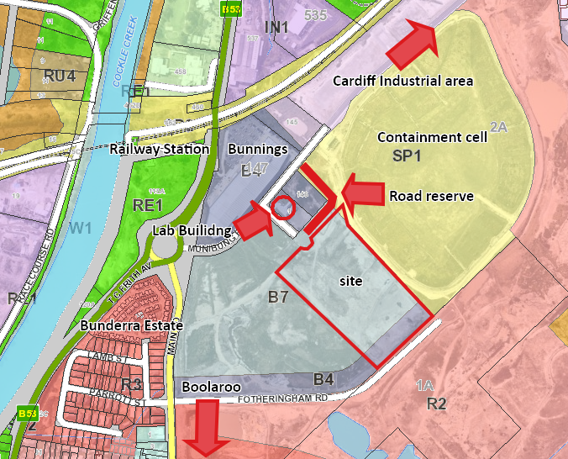

**Figure 1 – Development site, surrounding land uses and zoning**

The site is currently vacant and has been fully remediated as part of the overall site decontamination strategy.

The site falls approximately 3m from the bottom of an existing cut along the south eastern boundary, to northern corner.

North-east of the site is a containment cell associated with the decontamination of the Pasminco site; the cell will be maintained in perpetuity and is zoned SP1 Special activities.

South-east of the site is land zoned R2 Low Density Residential. Two applications for subdivision of these lands are currently under assessment by Council (DA/1522/2020 & DA/1525/2020).

South-west of the site is a vacant site zoned B4 Mixed Use and B7 Business Park, and is a second site identified for large format retail development.

North-west of the site are two lots zoned B4 Mixed Use. One of the sites contains the former Pasminco Laboratory building, and an application for commercial premises is currently under assessment by Council (DA/595/2020).

More broadly, the existing Boolaroo Bunnings and Cockle Creek Railway station are located north-west of the site, Cardiff industrial area to the north-east, Boolaroo township to the south, and recent residential development known as Bunderra Estate to the west.

## Proposal

Consent is sought for a retail premises with ancillary business premises, vehicle repair station, and service station, to operate as a Costco Wholesale warehouse.

The development comprises the following:

* Costco warehouse building with internal gross floor area (GFA) of approximately 13,100m2, consisting of:
  + retail floorspace,
  + ancillary business premises for preparation of products and provision of services (i.e. bakery, butcher, eye care),
  + ancillary food and drink premises,
  + four bay tyre fitment centre,
  + amenities and staff facilities.
* service station, consisting of:
  + 12 fuel pumps,
  + fuel canopy,
  + data hut,
  + pay at pump service
* 822 car parking spaces;
* landscaping;
* signage.

## Integrated Development Assessment

### Coal Mine Subsidence Compensation Act 2017

#### Section 22 Approvals for development within mine subsidence districts

The application was lodged as integrated development and the proposal was referred to Subsidence Advisory NSW (SA NSW). SA NSW provided General Terms of Approval (GTAs) dated 21 August 2020. GTA’s are included as recommended conditions of consent.

## Section 4.15: Potential matters for consideration

Applicable State, Regional and Local Environmental Planning Instruments and Policies are detailed hereunder. Where not explicitly detailed, it is considered those instruments or policies are not relevant to the proposal.

## Section 4.15 (1) (a) (i) the provisions of any EPI’s

### State Environmental Planning Policy (State and Regional Development)

The proposal is identified as regionally significant development under Part 4 Regionally significant developmentand Schedule 7 of the SEPP due to the capital investment value exceeding $30 million.

The Hunter and Central Coast RPP will be the consent authority for the application.

### State Environmental Planning Policy No. 33 – Hazardous and Offensive Development

The development includes the installation of a service station which includes underground fuel storage tanks, dispensers and associated pipe work. As the service station will store hazardous materials within the site, it is required to determine if the facility is a ‘potentially hazardous industry’.

The applicant has submitted a screening report which has been prepared in accordance with the *NSW Planning, Hazardous and Offensive Development Application Guidelines, Applying SEPP 33*. The report confirms the development is not a potential hazardous industry due to the distance of underground tanks from any boundary, the number of weekly deliveries.

As such the development is not potentially hazardous industry, and does not trigger further assessment provisions of the SEPP.

### State Environmental Planning Policy No. 55 – Remediation of Land

Under clause 7 of the SEPP a consent authority must not consent to the carrying out of any development on land unless:

1. it has considered whether the land is contaminated, and
2. if the land is contaminated, it is satisfied that the land is suitable in its contaminated state (or will be suitable after remediation) for the purpose for which the development is proposed to be carried out, and
3. if the land requires remediation to be made suitable for the purpose for which the development is proposed to be carried out, it is satisfied that the land will be remediated before the land is used for that purpose.

The site is located within the former Pasminco Lead Smelter site and Council’s records identify the site as contaminated.

The land, which includes the site, was provided with a site auditor statement in 2016 and Contamination Review in July 2020, which conclude the site has been remediated and is suitable for use for commercial/ industrial development. The site is therefore suitable for the development proposed.

Land contamination was also considered as part of approved subdivision (DA/834/2020) and was determined the land is suitable for the future commercial uses, with no further remediation works required.

#### State Environmental Planning Policy No. 64 – Advertising and signage

The signage indicates the name and business being carried out at the site, and is considered to be building / business identification signage for the purpose of assessment under the SEPP.

Under clause 8 of SEPP 64, a consent authority must not grant consent for any signage application unless the consent authority is satisfied the proposal is consistent with the objectives of the SEPP and with the assessment criteria contained in Schedule 1.

Signage is consistent with the aims and objectives of the SEPP, as it is compatible with the proposed development, provides effective communication, is suitably located and is of a high-quality design and finish.

The signage is considered to be consistent with the assessment criteria contained in Schedule 1 as detailed below.

|  |  |
| --- | --- |
| **Schedule 1 standard** | Proposal |
| 1. Character of area | Signage is size and scale which is consistent with the character of the locality. |
| 1. Special Area | Signage proposed will not adversely affect the amenity of the local area and will not impact on any significant items or landforms. |
| 1. Views and Vistas | Signage will not have an unexpected impact on views or vistas in the locality. |
| 1. Streetscape, setting or landscape | The signage is of an appropriate scale for the locality, does not protruding beyond any elevation and does not result in visual clutter. |
| 1. Site and Building | Signage is proportionate to the building and does not detract from important features of the site. |
| 1. Associated devices and logos with advertising structures | N/A |
| 1. Illumination | Illumination would not result in unacceptable glare, would not affect the amenity of any residential accommodation or impact on safety of pedestrians, vehicles or aircraft.  Illumination is not intended to be adjustable nor is it intended to be subject to a curfew. |
| 1. Safety | There would be not moving or flashing features of the signage and it is not considered to reduce safety for pedestrians or cyclist. |

### State Environmental Planning Policy (Coastal Management) 2018

The site is mapped within the Coastal Environment Area under the SEPP.

The subject site is highly disturbed from previous development and remediation work, and there would be no adverse impact to the integrity of biophysical, hydrological or ecological environments as a result of the development.

There will be no adverse impact to any heritage item or location.

All stormwater will be collected and drain to an approved public system, with on-site detention proposed.

The development will not adversely impact on the coastal environment.

### State Environmental Planning Policy (Infrastructure) 2007

#### Part 3, Division 5, Subdivision 2 Development likely to affect an electricity transmission or distribution network

In accordance with clause 45(2) of the SEPP, the application was referred to Ausgrid for comment. Ausgrid raised no objection to the development, subject to minimum clearances to electrical infrastructure being achieved. A copy of Ausgrid’s correspondence is attached in

Conditions of consent are recommended to ensure compliance with Ausgrid’s requirements. Where minimum clearances to overhead infrastructure cannot be achieved, it will be necessary for power lines to be relocated underground.

#### Part 3, Division 17, Subdivision 2 Development in or adjacent to road corridors and road reservations

The development includes a commercial premises in excess of 10,000m2 and provides in excess of 200 car parking spaces, and therefore triggers clause 104 Traffic-generating development of the SEPP.

The development was referred to Transport for NSW (TfNSW) (formally NSW Roads and Maritime Service) who provided a formal response to Council dated 5 November 2020. The response identified existing deficiencies in the local network which would be compounded by the development.

To mitigate the impact of the deficiencies, TfNSW have identified upgrades required at the major state road intersections of Munibung Road and TC Frith Avenue (the large roundabout adjoining the site), and the intersection at Munibung, Macquarie and Myall Road Cardiff. Subject to the upgrade works being in place prior to the issue of the Occupation Certificate (OC) for Costco, TfNSW raise no objection.

Site access construction and upgrades from Munibung Road approved as part subdivision DA/834/2020 are to be complete prior to trade commencing. Works include restriction of Hague Road to left in left out movements, and provision of a signalised intersection opposite to Bunnings ingress/egress, which will become a fourth leg of this intersection.

The proposed works have been discussed with TfNSW who have advised the works proposed as conditions of consent had been designed in consideration of the existing road reserve to ensure all works could be provided within the existing road reserve. these works confirms they can be contained within the existing road reserve without major modification and minimal environmental impact.

The upgrade works are to be included in recommended conditions of consent.

#### Part 3, Division 20 Stormwater management systems

Section 111A development permitted with consent, identifies that development for the purpose of a stormwater management system may be carried out by any person on any land.

The drainage works associated with the development are located within the SP1 Special Infrastructure zone. In accordance with the SEPP, these works are permitted in this zone with consent.

### Lake Macquarie Local /Environmental Plan 2014

#### Part 2 – Permitted or prohibited development

The development is a retail premises with ancillary business premises, vehicle repair station, and service station. The development will be located in the B4 Mixed Use and B7 Business Park zones.

Retail premises are a type of commercial premises, which is permitted in the B4 Mixed Use and B7 Business Park zones subject to development consent.

Service stations are permitted in the B4 Mixed Use and B7 Business Park zones subject to development consent.

The objectives of the B4 zone are:

* To provide a mixture of compatible land uses,
* To integrate suitable business, office, residential, retail and other development in accessible locations so as to maximise public transport patronage and encourage walking and cycling,
* To enable development that complements and enhances the core retail function and trading performance of Zone B2 Local Centre and Zone B3 Commercial Core.

The objectives of the B7 zone are:

* To provide a range of office and light industrial uses,
* To encourage employment opportunities,
* To enable other land uses that provide facilities or services to meet the day to day needs of workers in the area,
* To enable specialised retail premises and commercial uses that do not undermine the function of existing and future urban centres,
* To provide opportunities for high technology industries, scientific development and research activities.

The development provides a mix of compatible land uses including retail premises, business premises, vehicle repair station and service station which are consistent with the above objectives.

The development provides employment opportunities, and will not undermine the function of existing and future urban centres.

Retail will be the dominate use with ancillary business premises, vehicle repair station and service station all being operated as part of Costco Wholesale. Pursuant to planning circular PS 13-001 an ancillary use is one which is subordinate to the dominate purpose or serves the dominate purpose. In this instance the secondary uses identified will service the dominate purpose of retail. The vehicle repair station will only operate for fitment of tyre purchased from the retail store, business premises will relate to internal operations such as the optical concessions and hearing aid centre which are only be available to customers of the Costco retail store. And lastly the service station would only be available to Costco retail customers in a subordinate capacity to the main retail function of the site.

Drainage works associated with the development are located within the SP1 Special Infrastructure zone and permissible in accordance with SEPP (Infrastructure).

The objectives of the SP1 zone are:

* To provide for special land uses that are not provided for in other zones.
* To provide for sites with special natural characteristics that are not provided for in other zones.
* To facilitate development that is in keeping with the special characteristics of the site or its existing or intended special use, and that minimises any adverse impacts on surrounding land.

The use of the SP1 land for drainage infrastructure does not undermine the achievement of the zone objectives.

#### Clause 4.3 Height of buildings

The objectives of the building height standard is to ensure the height of buildings are appropriate for their location and to permit building heights that encourage high quality urban form.

A 15m maximum building height applies to the site. The development includes one main building and detached service station.

The main building has a height of 9.3m, with the highest point of the building being 12.1m in relation to roof mounted screening.

The service station has a maximum height of 5.7m.

#### Clause 7.1 Acid sulfate soils

The site is mapped as being affected by Class 5 acid sulfate soils (ASS).

Although no ASS are expected within the site, proposed works may have an effect on any ASS within the adjacent lots.

Based upon the extent of earthworks proposed, it is considered the works are not likely to lower the water table and as such will not have an impact on adjacent ASS areas.

#### Clause 7.2 Earthworks

Before granting consent, the consent authority must consider the implications of the development on the environment/locality in relation to earthworks.

The development site has a gentle slope from the base of existing cut at the rear of the site, to the front of the site.

Earthworks proposed relate to creating a level area on which the development is constructed, and provide an appropriate grade to the car parking area. To achieve this, excavations to depths of approximately 2m are proposed at the southern end of the site, with filling in the vicinity of 1m within the carparking area.

A batter is proposed along the south west edge of the site which will be located on the adjoining site. Owner’s consent has been provided for the batter in this location. Conditions of consent are recommended to ensure the batter is appropriate maintained and managed for any future development on the adjoining land.

All earthworks are complemented with appropriate stormwater management infrastructure to ensure no impact occurs on future adjoining development. Consideration has been given to erosion prevention and sediment control, with conditions recommended.

Due to the historical disturbance of the site, earthworks are unlikely to impact upon potential Aboriginal areas of significance.

#### Clause 7.13 Development on certain land at Boolaroo, Buttabah and North Wallarah Peninsula

The site is identified on the Key Sites map, within the former Pasminco and Incitec sites. This site pre-dates the more recent Key Sites map for large format retail referenced below.

Consent must not be granted unless a development control plan has been prepared, and the consent authority is satisfied vehicle access has been provided between Munibung Road, Cardiff and TC Frith Avenue, Boolaroo, and there are no significant land use conflicts between the development and the remediation of the remainder of the site.

Part 12 Precinct Area Plans, Section 12.15 Pasminco, of the Lake Macquarie Development control plan was adopted in February 2014 and addresses the requirements for a development control plan.

Munibung Road extension is now complete providing a direct link between Cardiff and TC Frith Avenue.

The site has been remediated, with ongoing monitoring requirements established for the contamination cell. The development will not impact the ability for these ongoing monitoring requirements.

#### Clause 7.21 Essential services

The consent authority must not grant consent unless it is satisfied the required essential services are available to serve the development.

The development has demonstrated the site is capable of being provided with required essential services and infrastructure including water, sewer, electricity, stormwater and vehicle access.

#### Clause 7.24 Development on certain land at 2A Main Road Boolaroo

The site is identified on the Key Sites map, within the Boolaroo Large Format Retail Site, former Pasminco Cockle Creek Smelter site.

Consent must not be granted unless the consent authority is satisfied the development,

* the development has a site area of at least 20,000 square metres, and
* the gross floor area of the retail premises is at least 13,000 square metres, and
* the resulting retail premises are to be operated by a single person.

The development covers an area of 68,512m2, provides a usable GFA in excess of 13,000m2, and is to be operated by Costco.

Whilst the retail floor area includes multiple uses being business premises, and vehicle repair station, these will function ancillary to the main retail land use. Therefore, GFA is calculated upon the parent use being retail premises.

## Section 4.15 (1) (a) (ii) the provisions of any draft EPI

No draft EPI’s which affect the development proposal.

## Section 4.15 (1) (a) (iii) DCP’s

### Lake Macquarie Development Control Plan (DCP) 2014

The site contains three different zoning, which results in both Part 4 Development in Business Zones and Part 5 Development in Industrial, Business Park and Infrastructure zones having weight. With the exclusion of landscaping and acoustic fencing it is noted that all works are generally contained in B7 zone and as such the development has been considered against Part 5 below.

#### Part 5: Development in Industrial, Business Park and Infrastructure Zones

#### 2.1 Site Analysis

Adequate site analysis documentation has been submitted.

#### 2.2 Scenic values

A visual impact assessment (VIA) has been submitted with the application. The VIA includes simulated views of the development from six points surrounding the development site demonstrated in figure 2 below.

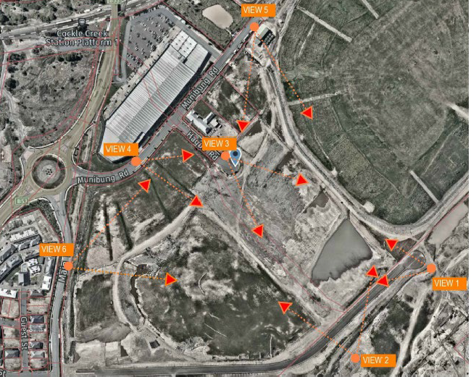

**Figure 2 Location of perspectives provided**

Council’s Scenic Management Guidelines locates the site within Scenic Management Zone 13 - hinterland, high settlement. This zone has a desired future character of encouraging development appropriate for town centres, including compact, higher density development with a mix of retail, business and residential uses, active street frontages, and a pleasant atmosphere for pedestrians and attractive streets. The character of buildings and the surrounding landscape should reflect the location and the popularity of these areas as social and recreational destinations. View corridors within the wider landscape are important and should be preserved and enhanced.

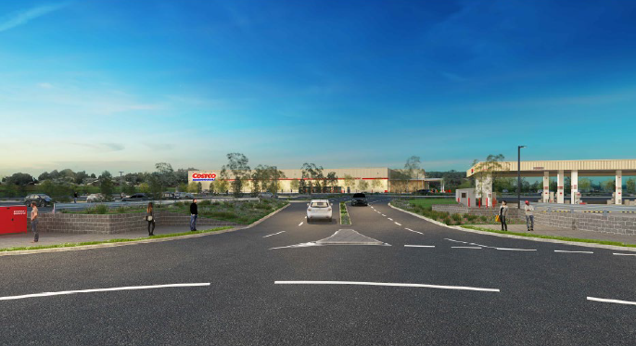

**Figure 3 - Perspective from view point 3 into the site**

The development is considered to be consistent with the expected visual impact for the locality and fit within the existing urban landscape without having a detrimental impact on the scenic values of the area. It is acknowledged visual impacts occur however these are appropriate for the expected development of the site, and have been mitigated through the design and siting of the building, and use of landscaping to the perimeter of the site.

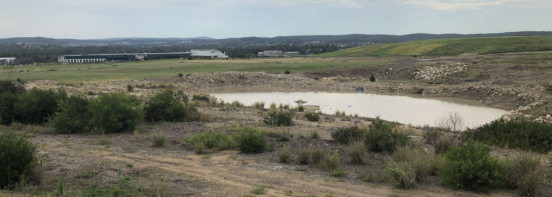

**Figure 4 looking north from First Street Boolaroo over the site, the containment cell on the right.**

The finished height of the building is approximately at RL30 (29.83m) with a 9.3m main building height. The summit of the containment cell (shown in figure 4) adjoining the development is RL45 with approximately 75% of the landform width being RL30. Hence views to the site from the north east, which includes elevated areas of Edgeworth and Glendale, are largely fragmented by the containment cell.

Views from Main Road and the west are apparent, however the proposed building form scale is consistent with the neighbouring Bunnings development.

The VIA relies on landscape provision throughout the car park and western perimeter of the site to ameliorate western views to the building from adjoining residential development and arterial roadways. This approach is supported, with amended plans provided demonstrating that adequate landscaping can be supported to achieve this outcome.

Local views from the east are mitigated by the building being cut into the landform by approximately 2m. A substantial landscape area is provided within the site along the Fotheringham Road boundary which will further ameliorate views of the roof of the building from the adjoining existing and future residential development.

Architectural perspectives identify the building colour as a cream/beige palette with red and blue highlights. No objection is raised to this colour scheme.

#### 2.3 Geotechnical

The site is identified as geotechnical zone T6 (low risk).

A geotechnical report has been submitted and deemed satisfactory by Council’s Development Engineer. This report recommends specific development limitations or criteria is obtained from SA NSW prior to development.

The application was referred to the SA NSW as integrated development, GTAs provided.

#### 2.7 Stormwater management

The development proposes stormwater management infrastructure that captures stormwater from the building conveying water to harvesting tanks for re-use within the development. Stormwater from hardstand areas will be captured through a series of pits and directed to an on-site detention. Overflow is discharged it to the public stormwater network to the north of the site, which has been designed to cater for future development of the site and adjoining development.

Council’s Development Engineer has assessed the stormwater management system and deemed it appropriate for DA purposes. A condition of consent is recommended to ensure detailed engineering design plans are submitted for the system as part of the Construction Certificate (CC) process.

#### 2.17 Social impact

Social impact has been addressed within the documentation submitted with the Statement of Environmental Effects (SEE). The proposal will provide social benefits through the provision of additional retail services and significant employment opportunities, and is appropriately located to minimise negative impacts on surrounding communities.

The development will help to revitalise the former Pasminco site, establishing this area as a large retail precinct, in accordance with the intended zoning of the land.

There is potential for negative impacts to occur from traffic and noise; these are addressed elsewhere within this report.

Council’s Coordinator for Social and Community Planning has reviewed the application and raised no objection to the findings provided by the applicant. The officer acknowledged the development is likely to positively contribute to the Lake Macquarie area and wider community.

#### 2.18 Economic impact

To complement the response included in the SEE, an Economic Impact Assessment (EIA) was submitted as part of amended documentation to support the application.

Council’s Economic Strategist has reviewed the development, supporting EIA and information within the SEE and supports the development providing the following advice;

The documentation identifies the development is expected to support 82 direct, and 131 indirect jobs during the estimated 12-month construction phase. During the operational phase, the development is estimated to create approximately 250 full-time jobs on the site, with an additional 225 jobs supported via multiplier effects in the broader economy.

Due to the Costco business model, diversity of product line, and significant trade catchment, the impact on sales of competing retail operators within the City and surrounding catchments is estimated to be approximately 1.5% of sales that would otherwise have been achieved without Costco entering the local market. This trade impact is considered relatively minor in nature and is unlikely to have a significant impact on the economic performance of surrounding centres.

The development will positively contribute to the City’s economy, without significantly impacting upon existing retail development in the City.

#### 3.1 Streetscape

Given the historical use of the site, and remediation works undertaken, the site and immediately surrounding lands are currently vacant of any built structures and vegetation.

The site and adjoining lands have recently been rezoned to enable commercial uses on the site, with a specific clause in the LEP introduced to enable large format retail development (subject to 13,000m2 minimum floor space) at the site. These actions indicate the expected character of the locality to comprise large buildings.

Built form located within the vicinity of the site comprises the existing Boolaroo Bunnings (corner of Munibung Road and TC Frith Avenue). This building presents a relatively unbroken elevation of approximately 270m to Munibung Road, with back of house facilities located between the building and landscape area adjoining the road reserve shown in figure 5.

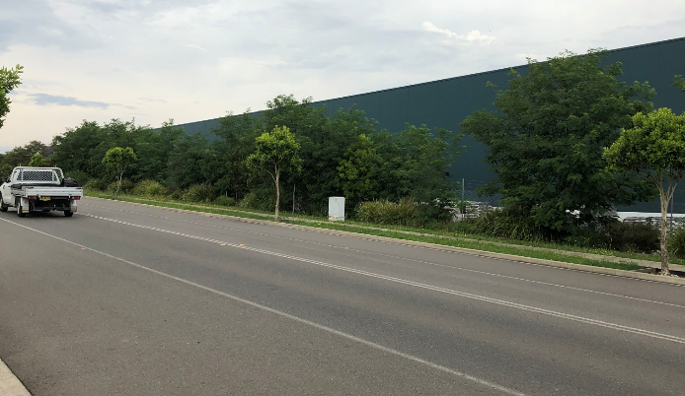

**Figure 5 – Bunning back of house orientated to Munibung Road**

The former Pasminco Laboratory Building is located to the north-west of the site, being physically separated from the Costco site by Hague Road and the approved road reserve. The laboratory building is elevated above existing road levels (shown in figure 6) in the area and will retain a prominent detached structure from the large format development proposed in the general area.

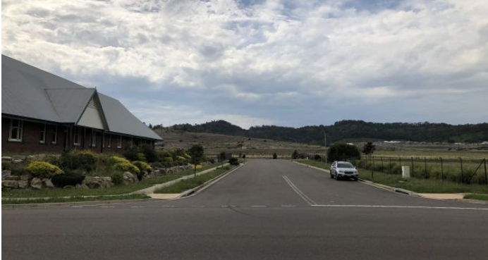

**Figure 6 - The Laboratory Building with views down Hague Road to the site**

The development is considered to provide appropriate streetscape outcomes that are consistent with the intended future outcome for development of the site. The main building comprises a single storey form which is set back significantly from the front boundary. Contextually the building is consistent with the nearby Bunnings building in terms of height and design. A site inspection of Costco Marsden Park was undertaken and it is anticipated the final out come will have a presentation similar to that in Figure 7 which demonstrates the outcome of the built form, car parking forward and landscape buffer. Once vegetation matures this would present an outcome which is conducive with existing development in the immediate locality.

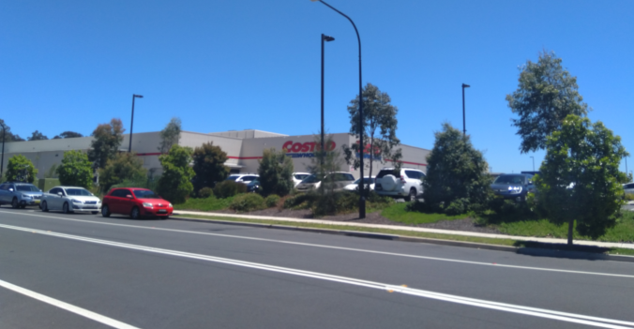

**Figure 7 - Costco Marsden Park street presentation**

The development also provides a readable entry feature to the western corner of the building, which presents to the future access road, Hague Road, and Munibung Road.

Substantial landscaping is provided throughout the site and to the site’s perimeters to further supplement the streetscape outcomes of the development.

The site adjoins Fotheringham Road to the rear. In this direction the development will present much of the back of house functions and includes a 2.5m acoustic fence and electrical substation. A 4.7m landscape buffer is provided between Fotheringham Road and acoustic fence which providing substantial screening of the fence and mitigating against the visual impact of the substation. It is considered that appropriate visual mitigation is provided to the Fotheringham Streetscape.

Visual impact and building bulk of the development has been considered elsewhere in this report, which accounts for the side and rear presentations of the development.

#### 3.2 Street setback

The development provides appropriate front setbacks.

The main building is set back in to the site by approximately 137m from the front boundary. The service station development has a setback of 27m from the front boundary.

Suitable landscaping is provided along the site frontage, having varied widths of 3.7-7m.

#### 3.3 Building bulk

The development is considered to provide appropriate building bulk outcomes that are consistent with the intended future outcome for development of the site, and that of existing development such as Bunnings.

The site and adjoining lands have recently been rezoned to enable commercial uses on the site, with a specific clause in the LEP introduced to enable large format retail development (subject to 13,000m2 minimum floor space) at the site. These actions indicate the expected character of the locality to comprise large buildings.

The main building will have a long axis of approximately 150m. The north-eastern elevation of the building will present to the containment cell and is unlikely to have any significant impact.

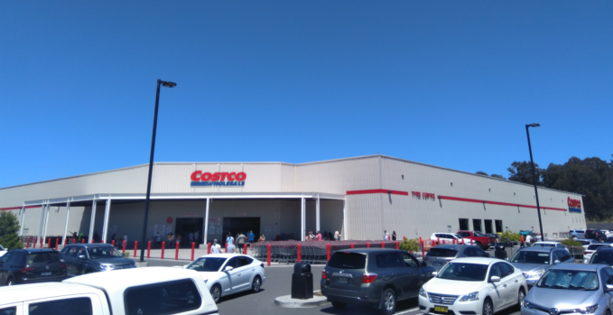

**Figure 8 - Costco Marsden Park main entrance**

The south-western elevation includes the main entrance of the development at the western corner of the building, which presents articulation to the public domain and main visible interface and will present similar Costco Marsden Park shown in Figure 8. This elevation is also broken up by the provision of the rear loading bay, which reduces the overall length and bulk of this elevation.

From the rear, due to existing site topography, any future residential development will be located at a height which overlooks roof structures. A significant area of landscaping is provided to the south-eastern boundary to ensure future development will only have filtered views of the building.

#### 3.6 Landscape design

An appropriate level of landscape design and documentation was provided to support the development.

Significant planting will be provided to all boundaries of the site, with all planter beds having a minimum width of 2m. Canopy tree planting is also proposed throughout the car park. Landscaping has been designed with consideration given to species and densities proposed that will be suitable for the site’s environment and will achieve long-term growth to mitigate the visual impacts of the building.

Council’s Landscape Architect has reviewed the landscape design and advised the outcomes are suitable to maintain long-term healthy vegetation growth. This will ensure the visual outcomes of the development and amenity outcomes within the site are achieved.

#### 3.9 Landscape and tree planting in car parks – B7 zone

The development provides 136 trees within the car parking area (this does not include tree plantings to the site boundaries). This complies with Council’s recommendations for one tree per six car parking spaces. The planting is proposed within structural soil modules which will accommodate suitable tree growth within the car parking area.

Council’s Landscape Architect has reviewed the documentation and confirmed the cell design proposed is suitable to sustain long-term tree growth. The officer has recommended conditions of consent.

#### 3.10 Fencing

Side fencing is proposed as 2.1m high black powder coated chainmesh fencing. This is considered consistent with existing fencing in the locality and black colour will ensure fencing does not contrast against landscaping or future building works.

Acoustic fencing is partially applied to the rear boundary at Fotheringham Road, Acoustic fencing is to 2.5m high of wooden construction. This fencing is located 4.7m in from the boundary with adequate landscaping provided between the fence and boundary to reduce visual impact. Fencing is appropriate for the locality to improve the amenity of future residential development to the south.

#### 3.11 Traffic and transport

A Traffic Impact Assessment (TIA) has been provided to support the application.

Impacts of the development to the state network have been considered in this report under SEPP Infrastructure.

The site will be accessed from a new public road which includes a signalised intersection on Munibung Road at the Bunnings ingress/egress and will wrap around existing lots to join Hague Road where it will connect to a new round about, in the approximate location shown in figure 9. The road reserve has been approved as part of DA/834/2020, with intersection upgrades to be carried out as works for the subdivision.

Hague Road will be restricted to left in left out onto Munibung Road, which will make the reserve road the primary site access point.

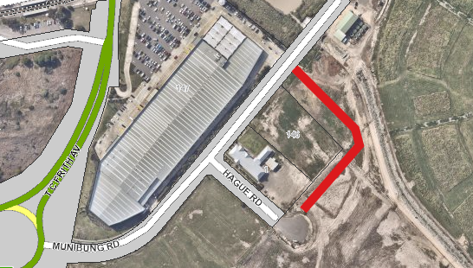

**Figure 9 - Approximate location of approved road reserve**

The development proposes three points of access to the site from the reserve road.

The access comprises:

* main central access via roundabout providing ingress and egress,
* access to the north-eastern corner of the site providing ingress and egress,
* access to the service station in the north-western corner of the site, providing ingress only.

The development also proposes a future link from the rear of the site to Fotheringham Road, once fully constructed and operational. The development will include the construction of an access to the rear boundary of the site, however access is not intended to be utilised at this time and will be closed off. The development does not rely upon the access to Fotheringham Road to adequately service the development and mitigate impacts to the state or local road network. As such this is a secondary option which may be adopted should future construction of Fotheringham Road be complete and be capable of servicing the development.

Concerns have been raised of the potential impacts to the local road network by Council’s Asset Management – Traffic officers. In particular the impacts of the development to Main Road, Boolaroo. In response to this concern, the applicant submitted an addendum to TIA. This documentation demonstrates a projected 14% increase to traffic along this road at PM Peak and 25% increase on the Saturday Peak, providing a projected maximum of 798 vehicle movements per hour in a south bound direction. Pursuant to Austroads Guide to Traffic Management Part 3 (2020), the typical mid-block capacity of a two lane undivided road is 900 vehicles per hour in an urban road. Based on this information, there would still be a minimum 11% capacity available in the local road at peak times post development. While the development increases traffic through the local road network, sufficient capacity remains to support the development and future development without requirements for upgrades.

#### 3.12 Design of parking and service areas

Internal parking and service areas have been appropriately designed to allow service vehicles and passenger vehicles to access all required areas of the site.

Vehicle turning movements have been demonstrated for b-double vehicles to service the loading bay and service station tanks. All heavy vehicle movements will be via the new service road in the north-eastern corner of the site, with no entrance or exit to occur for service vehicles from Hague Road.

Passenger vehicles can satisfactorily access car parking spaces in accordance with the requirements of AS2890.1. All parking spaces provided are generous in size, exceeding the minimum requirements of the Australian Standard.

Potential for the provision of electric vehicle charging was discussed with the applicant, it was advised that Costco is not an authorised electricity reseller. It was considered engaging a third party to operate electric vehicle charging on the site would result in a second operator would impact permissibility under Clause 7.24 of the LM LEP which requires a single operator.

#### 3.13 Bike parking and facilities

A bicycle storage area catering for ten bicycles has been provided at the front of the store for customers, and another storage area provided for staff bicycles at the rear of the building. Lockers are provided for the storage of personal items.

This provision of facilities is considered to be appropriate. Given the style of retail associated with Costco (i.e. selling items in bulk quantities), it is unlikely customers would arrive at the site via bicycle. Staff may arrive at the site via bicycle.

#### 3.14 Motor bike parking

No designated motor bike parking has been provided. However a surplus of car parking has been provided which is considered suitable to cater for the required motor bike parking.

#### 3.15 Car parking rates

Part 5 of the DCP does not specifically prescribe a parking rate for retail, however does include a rate for bulky good premises, which is considered an appropriate comparable rate. The rate is two spaces, plus one space per 40m2 GFA.

The development has an approximate floor area of 13100m2 which would required 327.5 plus two spaces

A total of 329.5 spaces are required.

The development provides 822 car parking spaces comprising the following,

* 779 customer spaces including 18 accessible spaces,
* 8 tyre centre spaces,
* 35 staff spaces

The development proposes 249% of required parking or an excess of 149%.

The applicant reviewed parking as part of the TIA addendum provided. This looked at previous similar development which Costco had complete and number of parking spaces provide. All development had similar number of spaces with Perth providing a higher rate per 100m2 of parking, Ipswich being relatively similar and Epping being half a space less per 100m2. This demonstrates the development is of a type which generates significant parking requirement in each of its localities and is supported in this instance.

#### 3.16 Non-discriminatory Access

An Access Report was submitted with the application.

Council’s Ageing and Disability Officer and Acting Chief Building Surveyor have reviewed the documentation and confirmed the development has the ability to comply with all access requirements. Conditions of consent have been recommended.

#### 3.17 Safety and Security

Documentation assessment the development against the principles of Crime Prevention Through Environmental Design (CPTED) was submitted. To mitigate potential issues, strategies have been incorporated in to the development including providing appropriate lighting, installing CCTV, providing way finding signage, and implementing vegetation and building maintenance strategies.

Crime statistics for the locality include the following crime types which may affect the development,

* steal from motor vehicle,
* break and enter non-dwelling,
* steal from retail store, and
* malicious damage to property.

Council’s Planner for Youth and Safer Communities has reviewed the information provided and concurred with the findings provided. The officer has recommended conditions of consent.

#### 4.1 Demolition and construction waste management

Conditions of consent are recommended to ensure a construction waste management plan is provided to and approved by the certifying authority prior to issue of the first CC.

#### 4.2 Operational waste management

#### Suitable waste facilities are provided by way of a waste storage and compactor area at the rear site adjacent to the loading dock. The applicant has confirmed the site can be serviced by a private waste contractor.

Conditions of consent are recommended to ensure an ongoing waste management plan is provided to and approved by the certifying authority prior to issue of the first CC.

#### 4.5 Erosion and sediment control

There development results in a significant area of disturbance.

Council’s Sediment and Erosion Control Officer has raised concern with the erosion and sediment control plans provided.

To ensure appropriate measures are implemented prior to, during and following construction, conditions of consent are recommended requiring an amended Soil and Water Management Plan to be provided to and approved by the certifying authority prior to issue of the first CC.

#### 4.6 Air quality

The operation of the site does not raise significant concern for impact on air quality being a large format retail store.

The location of the service station does not raise concern that it would adversely impact on the air quality of any adjoining land users.

Standard conditions of consent are recommended to ensure construction works do not affect adjoining land users by impact to air quality through dust creation or other means.

#### 4.7 Noise and vibration

The development includes the following operational hours:

* main retail premises: 8am to 9pm
* service station: 6am to 10pm
* staff access: 4am-10pm (cleaning, stocking and administration duties)
* deliveries: 24 hours a day

All operations are proposed seven days a week.

An Acoustic Assessment has been provided, which demonstrates the development can achieve required internal comfort levels to nearest residential receiver, subject to the provision of an acoustic fence at the rear of the site. Once the acoustic fence is constructed, the loading dock would emit a predicted noise level of 35dBA when measured from the nearest residential development for all hours of operation.

#### Part 9.15 Service Stations

The development provides appropriate landscaping to Hague Road and the new road reserve to mitigate the visual impacts. It is noted the service station is pay at pump only with no convenience store component which reduces the visual impact of the structure.

The service station component will not impact on any future residential land users.

There will be no designated storage or parking associated with the service station component as it is ancillary to the main retail function of the site.

Casual surveillance will be provided, with the development located at the prominent street front location within the site, with crime risk being addressed as part of the overall development.

The cover over forecourt will have a maximum height of 5.77m above finished ground level which is appropriate.

Non-discriminator access has been addressed over the site as whole.

An overall waste management plan has been provided.

#### Part 9.17 Signage

#### 17.1 Design

Signage proposed is of a design and scale which is compatible with both the size of the building and corporate branding of Costco.

Signage will generally be affixed to the building, with one free standing sign proposed for advertising of fuel prices forward of the service station.

#### 17.2 Positioning

Signage has been located and designed to not clutter the building, covering only a relatively small portion of the three elevations on which the signs are located. Suitably sized signs are proposed on each side of the fuel canopy over the service station.

There would be no risk to public safety or impact on traffic control devices as a result of signage proposed.

#### 17.3 Specific sign dimensions

The main building includes five flush wall mount signs. Signage on the south-west elevation covers 3.5% of the elevation, signage on the north-west elevation covers 4.5% of the elevation and signage on the north-east elevation covers 2.7% of the elevation. This outcome is considered appropriate.

Signage provided to the fuel canopy over the service station forecourt is considered to be fascia signs. These signs do not project above the canopy and only take up a maximum of 9% of the fascia for any elevations. This outcome is considered appropriate.

The free standing fuel price sign has dimension of 2m (w) x 2.8m (h) and extends to ground to ensure there is no safety issues. This outcome is considered appropriate.

#### 17.4 Illuminated, flashing and moving signs

Signs are provided with a combination of internal and external illuminations methods. No sign will flash, move or create significant glare. Illumination would not result in signage conflicting with or resembling and traffic control device.

#### Part 12.15: Pasminco Area Plan

Controls within the Area Plan generally relate to broader redevelopment of the site as a whole rather than individual development of sections of the site. The following sections are relevant to individual development.

#### 5 Employment lands

Potential impacts to the amenity of future adjoining residential lands has been considered within this assessment. Internal comfort levels can be achieved for all future dwellings, and visual impact has been ameliorated.

#### 7 Heritage conservation and interpretation

The site is not identified as being within a heritage conservation area, or containing any heritage items listed in Schedule 5 of LM LEP 2014, or within a sensitive aboriginal landscape area. However the site has an industrial heritage of which controls have been developed under the Area Plan, with consideration also given to interpretation works to acknowledge the traditional owners of the land.

A heritage interpretation strategy for the land was developed and adopted in 2015. The strategy provides information regarding interpretation techniques, potential content and several examples.

The development provides two sets of heritage interpretation. An indigenous interpretation element is located at the front of the site along the reserve road, and a second industrial heritage interpretation element is located at the rear of the site and orientated to Fotheringham Road and future residential development.

Council’s Heritage Planner has reviewed the interpretation concepts and advised they satisfy the outcomes of the strategy for DA consent. Conditions of consent are recommended to require further detail of the interpretation elements prior to the issue of the first CC.

## Section 4.15 (1) (a) (iv) any matters prescribed by the regulations

No matters affect the development proposal

## Section 4.15 (1) (b) the likely impacts of the development

#### The likely impacts of the development contained in this part of the Act have been detailed throughout the assessment report.

Due to the scale of the development, amenity impacts associated with construction works may arise. A condition of consent is recommended requiring a detailed Construction Management Plan (CMP) to be prepared prior to construction commencing detailing methods of limiting impacts.

## Section 4.15 (1) (c) the suitability of the site for development

#### Does the proposal fit the locality?

The development is considered to fit the locality. The development is consistent with the surrounding commercial land uses, fits into the existing commercial character and poses no significant adverse impacts.

#### Are the site attributes conducive to development?

As demonstrated in this report, the site is conducive to the development proposed.

## Section 4.15 (1) (d) any submissions made in accordance with this Act or the Regulations?

#### Public submissions:

The application was notified from 11 August 2020 until 28 August 2020.

A total of five submission were received from three parties. All submissions were in objection to the development. Three responses were received in relation to the development during the notification period, and a further two were received after the formal notification period.

Key issues raised within the submissions are as follows:

* visual impacts,
* acoustic impact to residential zoned land to the south,
* connection to and construction of Fotheringham Road,
* intersection upgrade works,
* location of services,
* compliance with Clause 7.13 of the LM LEP 2014,
* compliance with Clause 7.24 of the LM LEP 2014,
* economic impact,
* compliance with zone objectives.

These matters have been considered and are addressed within the relevant sections of this report.

## Section 4.15 (1) (e) the public interest

The development is considered the achieved balanced and orderly outcomes, and is in the public interest.

The application provides a development that is consistent with the zoning of the land and has demonstrated compliance with relevant controls.

The development has demonstrated no significant amenity impacts will arise now or in the future, subject to the imposition and compliance with recommended conditions of consent.

## Section 7.12 Fixed development consent levies

The development is subject to development contributions under the Lake Macquarie Section 7.12 Contributions Plan – Citywide 2019.

Applicable contributions will be levied upon the development and triggered by recommended conditions of consent.

| Staff endorsement |
| --- |
| The staff responsible for the preparation of the report, recommendation, or advice to any person with delegated authority to deal with the application has no pecuniary interest to disclose in respect of the application.  The staff responsible authorised to determine the application have no pecuniary interest to disclose in respect of the application.  Signed:  Glen M Mathews Signature  Glen Mathews  Senior Development Planner  Development Assessment and Certification |
| Senior endorsement |
| The staff responsible for the preparation of the report, recommendation, or advice to any person with delegated authority to deal with the application has no pecuniary interest to disclose in respect of the application.  The staff responsible authorised to determine the application have no pecuniary interest to disclose in respect of the application.  Signed:    Amy Regado  Acting Chief Development Planner  Development Assessment and Certification |